Trent Giever

CS 140

Professor Debbie Wolf

2/6/19

Ch 6

1. Bill Bates added to AD

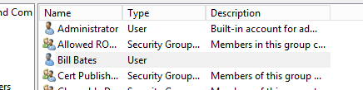

1. Content type, bill gates manager of it
   1. Created the content type



* 1. Uploaded the template for the word document

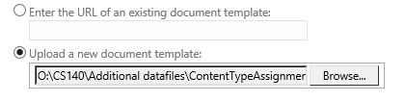

* 1. Assign Debbie Wolf as the workflow approver

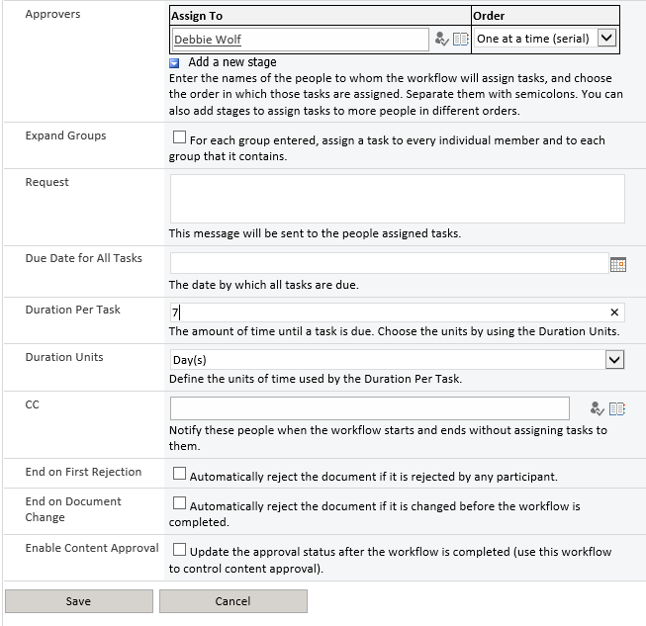

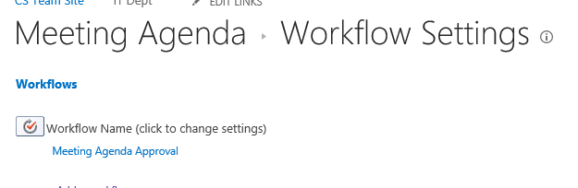

* 1. 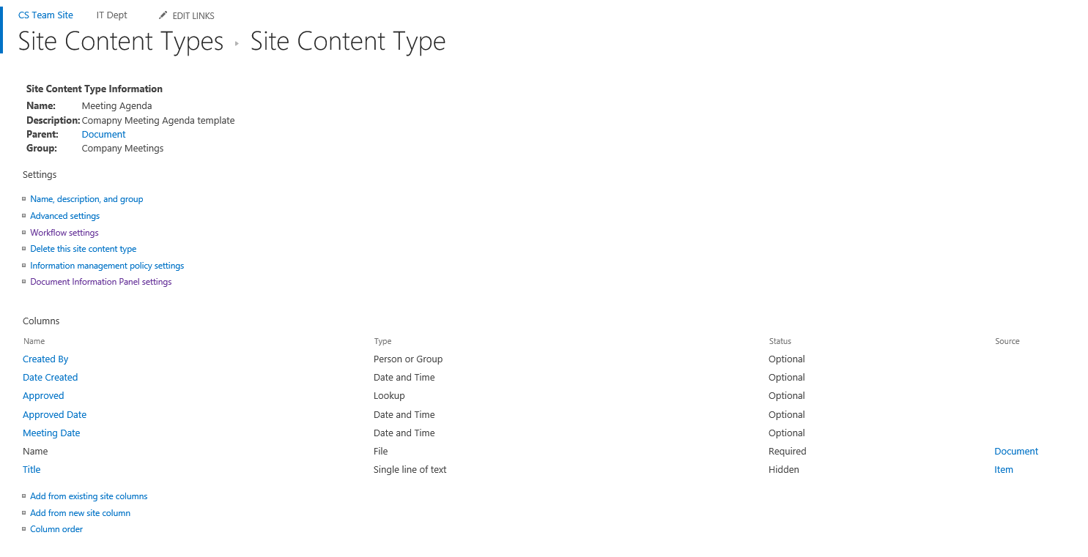Columns created
  2. Add content control in the library

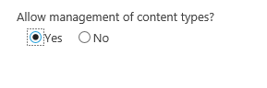

* 1. Add the content type

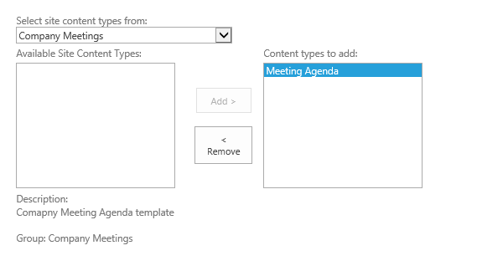

* 1. Removing the document content type from the library

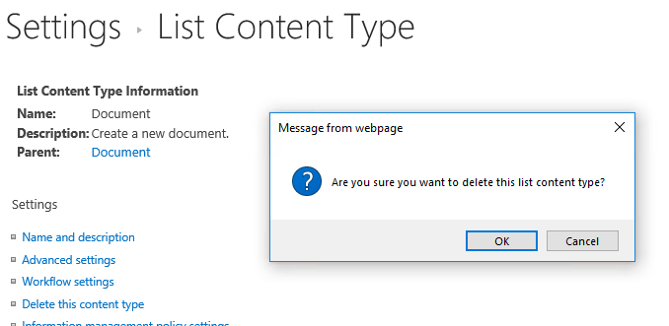

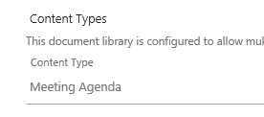

* 1. Changed the document library to bill bates

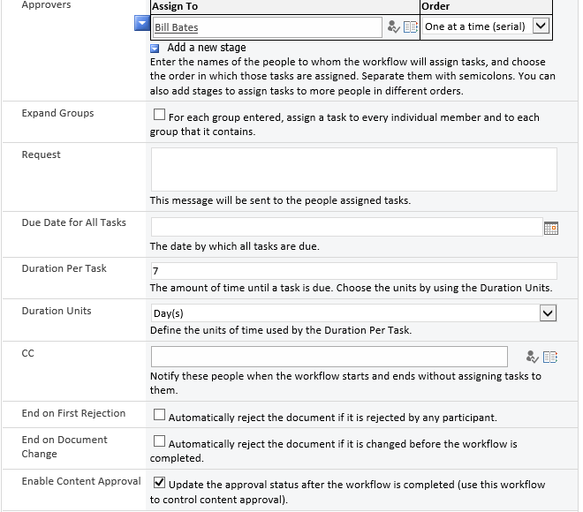

1. 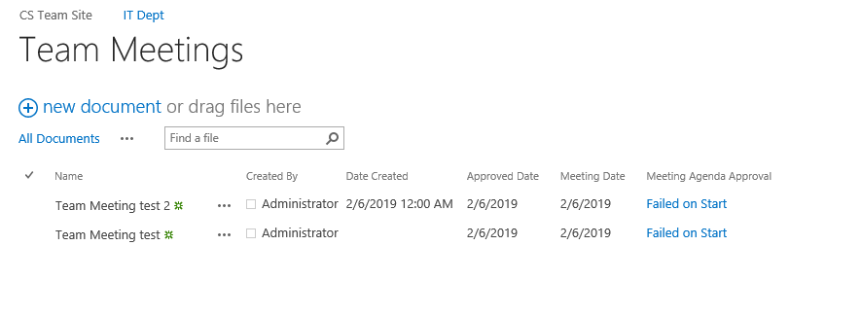Sample test files created
2. Steps
   1. Created the document library on the it dept site
   2. Created a content type on the main site page
   3. Added the needed columns
   4. Added the word template to the content type
   5. Activated the workflow in settings
   6. Added the workflow with Debbie Wolf as the approver in the content type
   7. Got back into the document library
   8. Added the ability to control content types
   9. Added the content type
   10. Removed the document content type from the it library
   11. Verified Bill Bates had the right to approve of documents only for the library
   12. Changed the view to have the desired items show
   13. Lastly did 2 test files to make sure it was working, and the workflow would not start with the settings in place